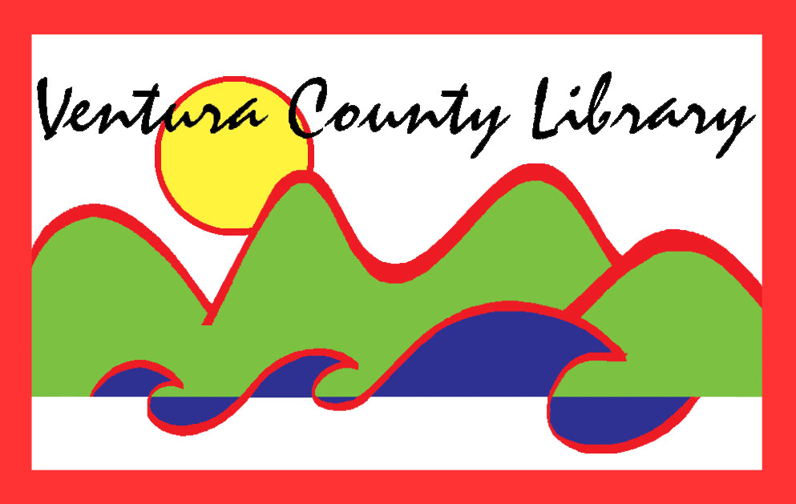

VENTURA COUNTY LIBRARY

5600 Everglades St., Suite A, Ventura, CA 93003

vencolibrary.org

FOR IMMEDIATE RELEASE
September 17, 2019

SUBJECT: Susan Orlean Presents The Library Book – A special One County, One Book author event – at California State University Channel Islands
CONTACT: Nancy Schram, Ventura County Library Director, (805) 256-8535
Ron Solórzano, Regional Librarian, (805) 218-9146

DATE: November 2, 2019; 2-4 p.m.

Journalist and bestselling author Susan Orlean comes to California State University Channel Islands’ Grand Salon (1 University Drive, Camarillo, CA 93012) from 2-4 p.m. on Saturday, November 2, 2019, to talk about The Library Book. This special event is a part of the Ventura County Library’s second annual One County, One Book community reading program. During this event, Orlean discusses The Library Book in a session followed by a Q&A moderated by Stacie N. Galang, Editor and Content Coach with the Ventura County Star. A book signing follows, with copies available for purchase.
This author program is made possible through a primary sponsorship from California State University Channel Islands (CSUCI), and additional sponsorships from a host of other organizations including California Lutheran University, Ventura College, the Museum of Ventura County, the Museum of Ventura County's Docent Volunteer Council, the Camarillo Public Library, the Calabasas Library, the Ventura Friends of the Library, the Ojai Valley Library Friends & Foundation, and the Ventura County Library Foundation. Seating for this event is on a first-come, first-served basis. Tickets are not required, but we ask that you RSVP by visiting bit.ly/vclocob.
One County, One Book aims to unite the Ventura County community around a common narrative, spreading interest in and facilitating discussions about the selected book. The Library Book chronicles the 1986 Los Angeles Public Library fire and its aftermath to showcase the larger, crucial role that libraries play in our lives. Orlean delves into the evolution of libraries across the country and around the world, from their humble beginnings as a metropolitan charitable initiative to their current status as a cornerstone of national identity.
From the everyday to the outlandish, Orlean has an eye for the moving, the hilarious, and the surprising. Considered “a national treasure” (The Washington Post), she is the author of The Orchid Thief, which inspired the Academy Award-winning film Adaptation, and Rin Tin Tin, which tells the remarkable story of how an orphaned puppy became one of the best-paid actors in Hollywood. The Library Book is her latest work, and explores the notorious cold case of who set fire to the Los Angeles Public Library in 1986, destroying 400,000 books. The Library Book is a Washington Post Top 10 Book of the Year, a New York Times Bestseller, and a New York Times Notable Book of 2018.
In addition to Orlean’s visit, people across the county have a chance to attend a variety of other events in October, 2019. Events in our One County, One Book lineup include screenings of the 2018 film The Public, a faculty panel hosted by California Lutheran University, library- and book-themed classes and activities for children, book discussion groups for adults led by library staff, and more.
Other program partners are also contributing to the One County, One Book program by hosting book discussion groups and related programming, making copies of the selected title available for checkout, publicizing the program, or creating other opportunities for community members and students to participate and be involved. These partners include the Thousand Oaks Library and the Oxnard Public Library. Details on this year’s program, our partners, and our slate of events can be found by visiting www.vencolibrary.org/ocob.
To participate in One County, One Book, pick up a copy of The Library Book from one of our 12 library branches. In addition to our regular holdings, beginning in October each library will have an “Honor Book Shelf” set up with additional copies. You can take one of these special copies to read and return it when you are done or pass it on to a friend. You can even donate a new copy for others to enjoy!
All events associated with One County, One Book are free and open to the public. For more information about the 2019 One County, One Book program, visit www.vencolibrary.org/OCOB or contact Ron Solórzano at ron.solorzano@ventura.org or 805-218-9146.
The Ventura County Library is available 24/7 at www.vencolibrary.org. Please visit our website for information on the location and hours of the library closest to you.

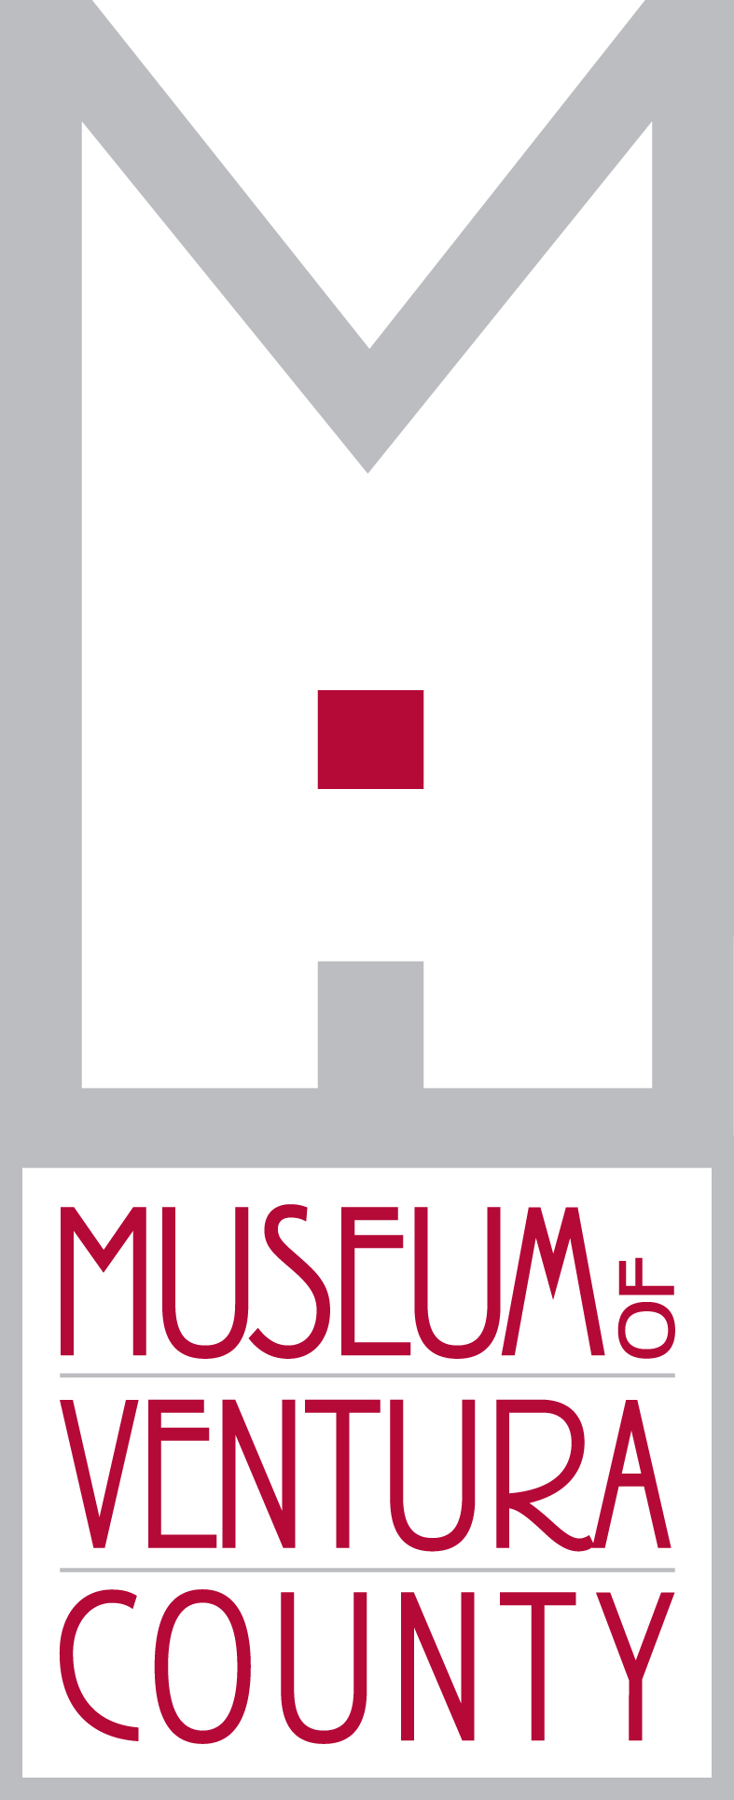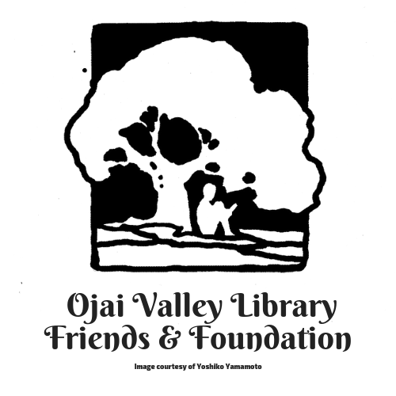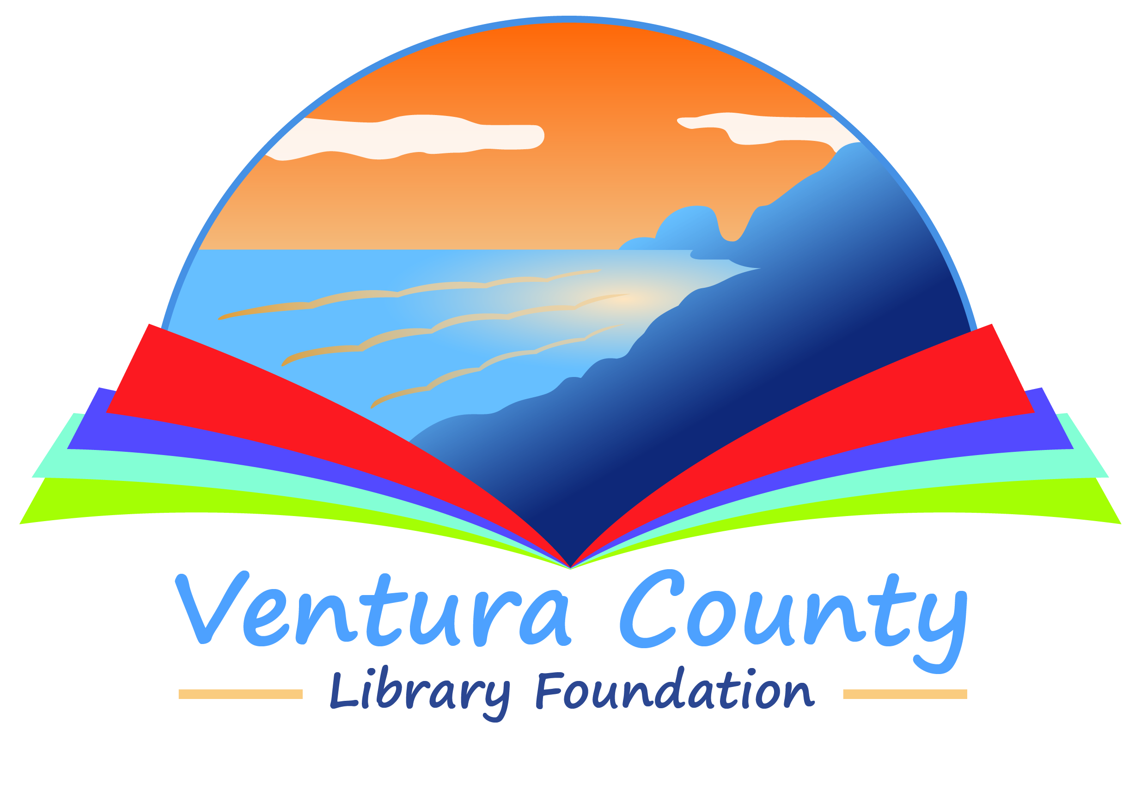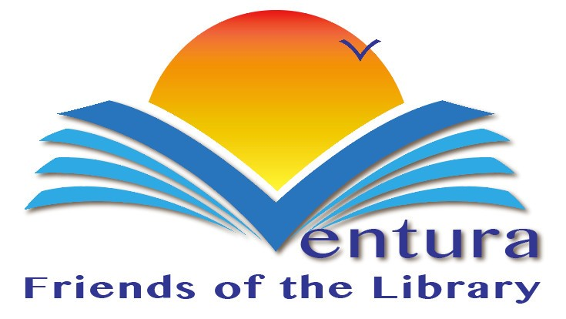
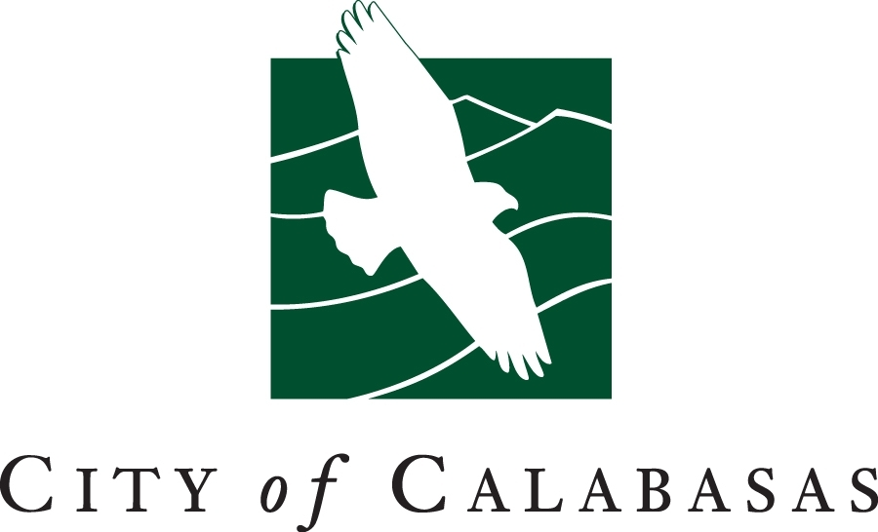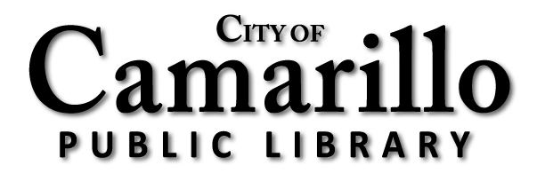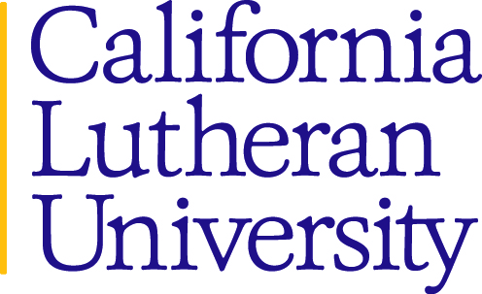
Ventura County Library:
Inspiring our community to explore, discover and connect.
The Ventura County Library is available 24/7 at www.vencolibrary.org.

Ventura County Library has 12 locations across the County:
El Rio Branch:
- Albert H. Soliz Library, 2820 Jourdan Street, Oxnard, CA 93036
Heritage Valley branches:
- Fillmore Library, 502 2nd Street, Fillmore, CA 93015
- Piru Library, 3811 Center Street, Piru, CA 93040
Oak Park branch:
- Oak Park Library, 899 North Kanan Road, Oak Park, CA 91377
Ojai Valley region branches:
- Meiners Oaks Library, 114 North Padre Juan, Ojai, CA 93023
- Oak View Library, 555 Mahoney Avenue, Oak View, CA 93022
- Ojai Library, 111 East Ojai Avenue, Ojai, CA 93023
Port Hueneme branch:
- Ray D. Prueter Library, 510 Park Avenue, Port Hueneme, CA 93041
Ventura region branches:
- Avenue Library, 606 North Ventura Avenue, Ventura, CA 93001
- E.P. Foster Library, 651 East Main Street, Ventura, CA 93001
- Hill Road Library, 1070 S. Hill Road, Ventura, CA 93003
- Saticoy Library, 1292 Los Angeles Avenue, Ventura, CA 93004
See our hours of service at https://www.vencolibrary.org/locations
###
If you would prefer not to receive these event notices in the future, simply reply to this email
with UNSUBSCRIBE in the subject line.

